Automation Suite Analytics

**What is Automation Suite Analytics in FireFlink?**

Analytics is a systematic computational analysis of suite data or suite statistics, which contains brief information about Automation suites created.

* **Navigation steps to " Automation Analytics":**
* Login to FireFlink.
* The user will be landed on the All Projects level Project Menu.
* Users can navigate to individual projects either by creating new ones or by selecting existing ones.
* The Analytics section can be found in the left navigation panel after navigating to an individual project.
* Once landed on the analytics page, by default the Automation suite tab will be selected.
* The analytics section should not display before executing the suite.
* Users can see the empty analytics as shown in the below screen, which has no suites executed. 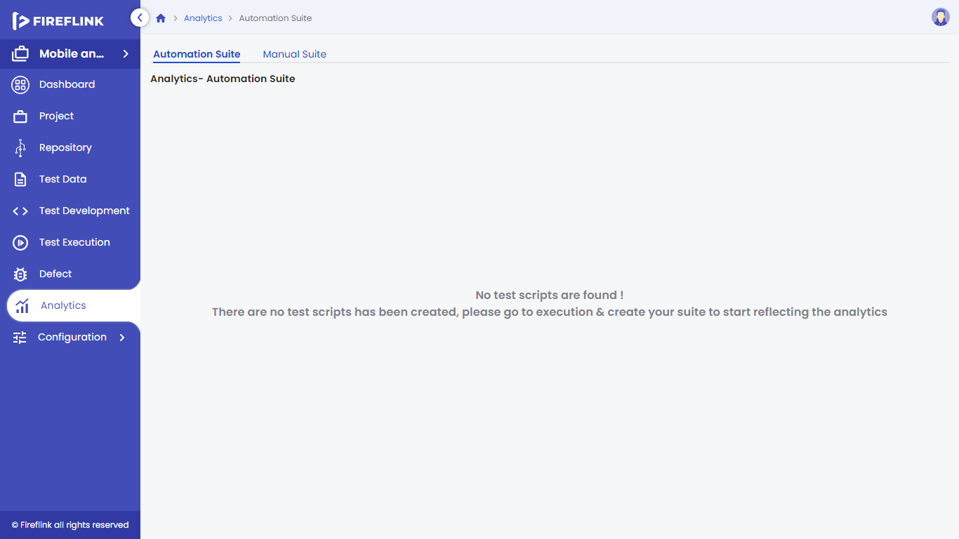
* Once you create and run a suite, it will appear in the analytics section, as shown below.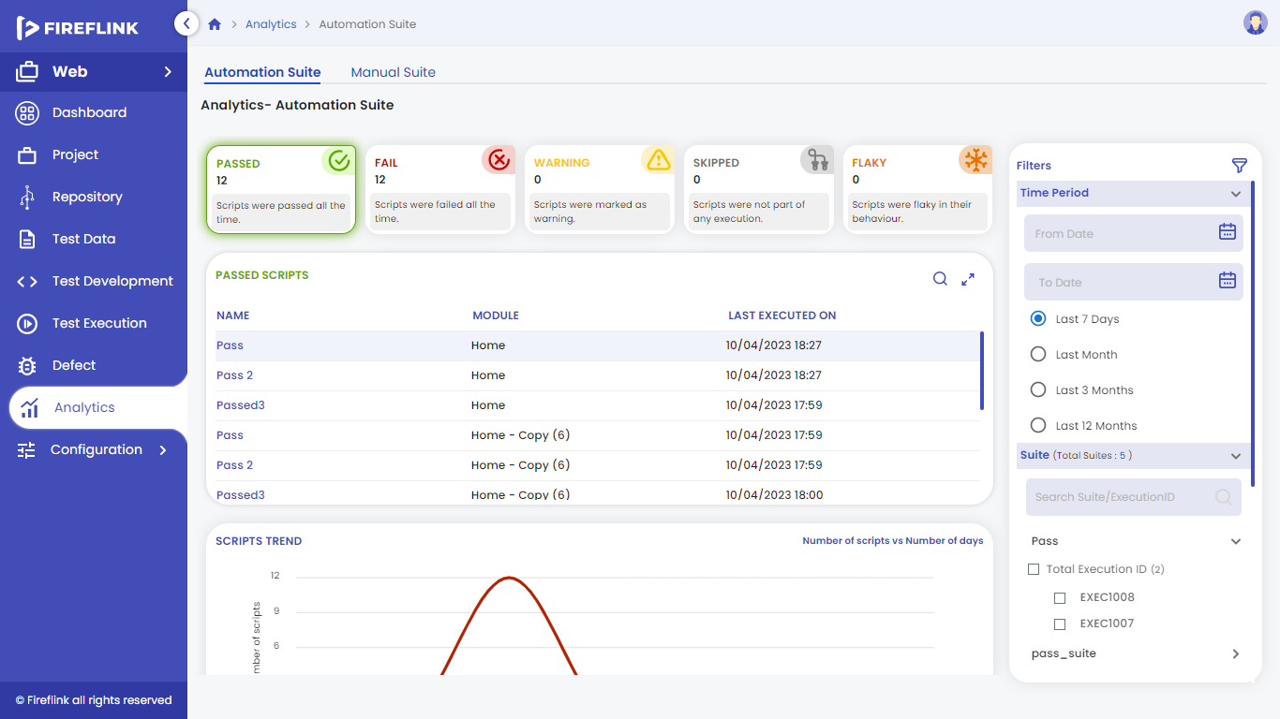
* "Analytics" provides detailed information about the suites.
* Here we can check the status and efficiency of the suites as shown in the above graphical representation.

Under Analytics, users can use various filters, such as: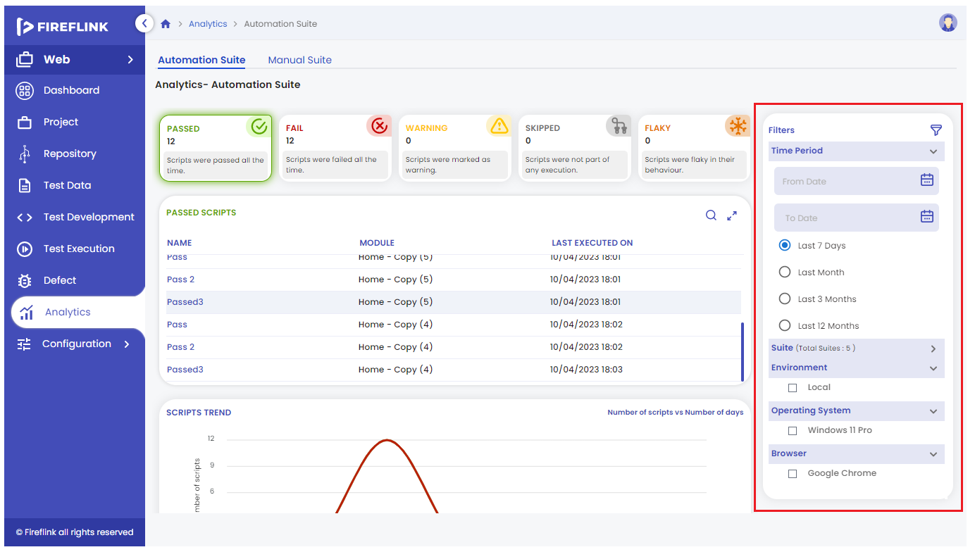

1. **Time Period**

* After execution, if a user navigates to the Analytics section, in the expanded time period component, by default it will select the last 7 days' radio button and it will display the last 7 days of the analytics report.
* Users can choose whether they want last month's analytics report, the last 3 months' analytics report, or last year's analytics report.
* Users can also get the reports for the duration by selecting "From date" and "To date".

1. **Suite (Total suites: count)**

* Whenever the user expands the suite component, it will display all the suite files which are executed.
* Users can select any one of the suites to get analytics.

1. **Environment**

* It will display the Execution environments such as Local, Browser stack, etc.
* Users can select the environment just by clicking on the checkbox of the particular environment in which execution has to be done.

1. **Operating System**

* It will display all the OS like Windows, Linux, and iOS.
* Users can select the operating system by clicking on the check box.

1. **Browser**

* All the browsers like Google Chrome, Opera, Microsoft Edge, and Mozilla Firefox will be displayed in the browser section.
* Users can select the browser just by clicking on the check box.

**Analytics - Automation Suite**

1. **Cards**: If the user wants to get into Passed scripts, Failed scripts, warning scripts, skipped scripts or Flaky scripts tables then, they just have to click on a particular card. Respective details of the script will be displayed in the below table present.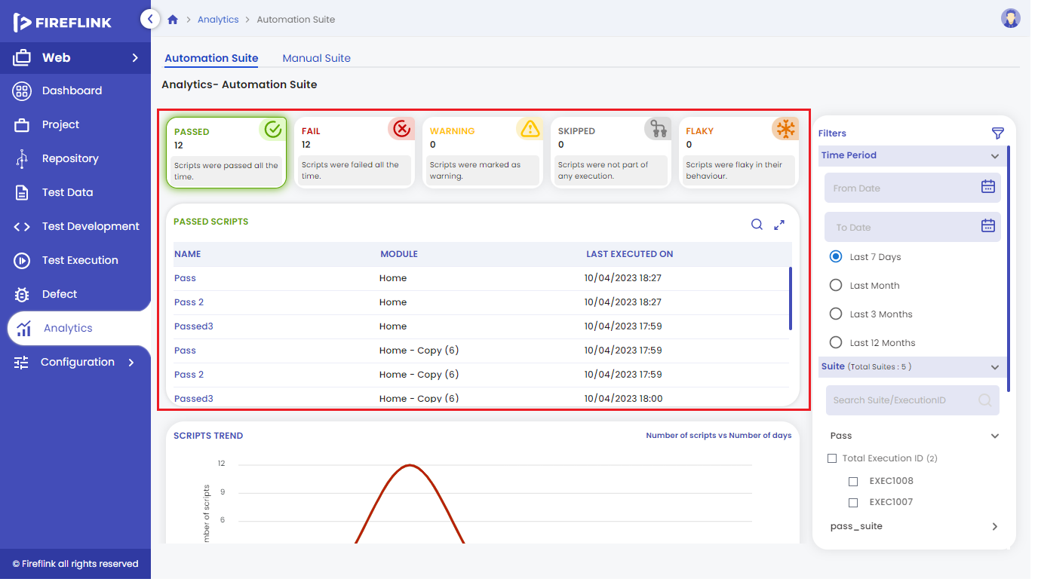
2. **Scripts Trend** graph
   * Based on the time period and suite selected, the script trend will display the graph.
   * When the user hovers the mouse on the line graph, it will display a tooltip stating Passed, failed, Warning, Skipped, and Flaky scripts as shown in the below design. 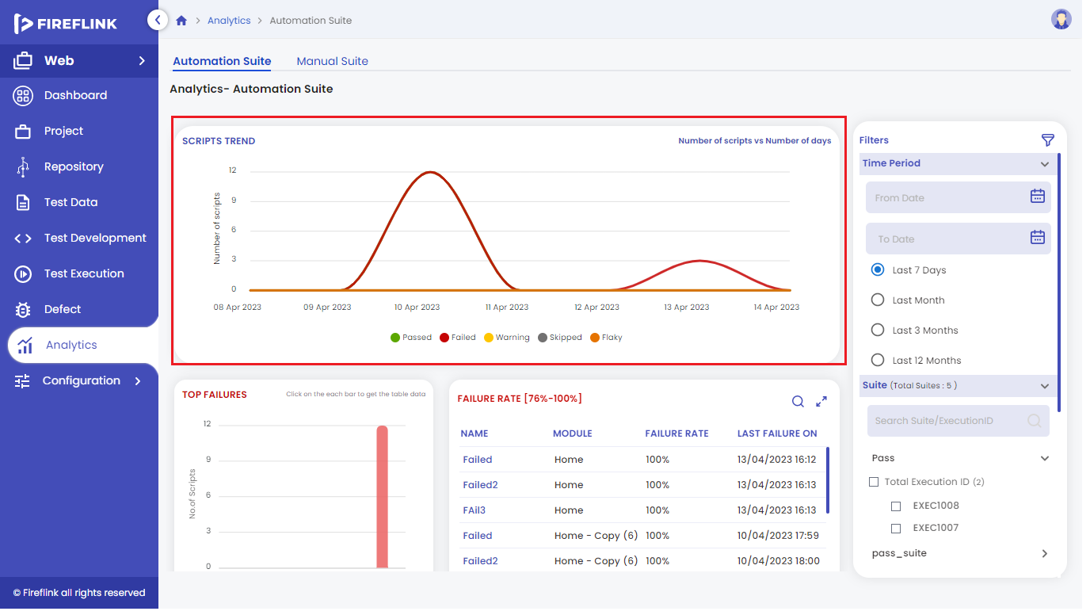
3. **Top Failures**
   * The top Failures section is represented by the bar graph and in the form of the Failure Rate.
   * Where the bar graph displays the ratio of the number of scripts proportional to the failure rate.
   * The failure rate table displays the failed scripts, as per the selecting percentage of the bar graph as shown below. 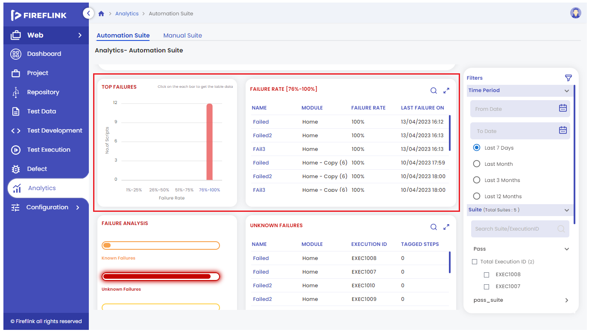

1. **Failure Analysis**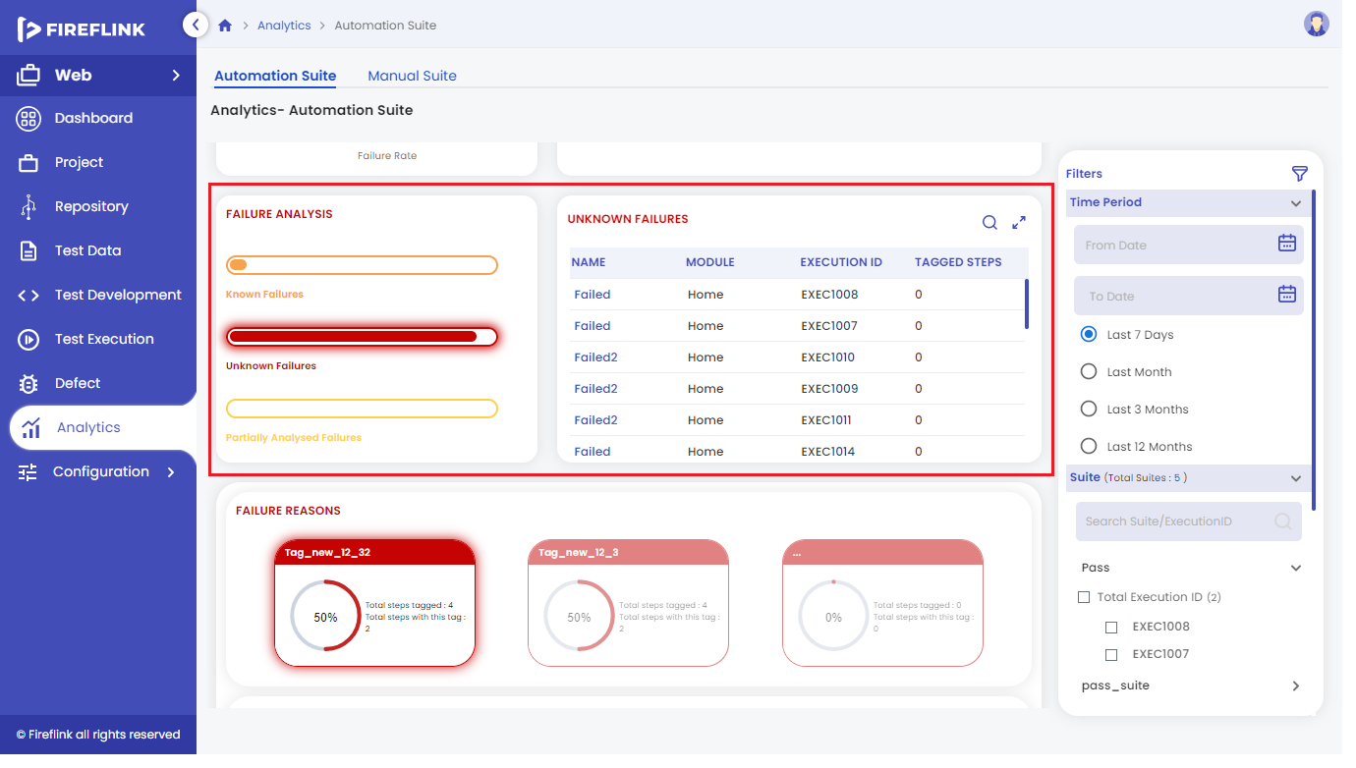
2. **Known Failure**

* Scripts which are failed and tagged are considered as known failures.
* The Known scripts section is represented by the bar graph and in the form of a table chart.
* Whereas, the bar graph displays the percentage of the tag which is mentioned in the scripts.
* The tag table chart displays the tagged steps and the table contains Name, Module, Execution ID and Tagged Steps (It displays the number of steps tagged in the scripts) as shown below.

1. **Unknown Failure**
   * Scripts which are failed and not tagged are considered as Unknown failures.
   * Unknown scripts are represented by bar graphs and in the form of a table chart.
   * Whereas, the bar graph displays the percentage of the non-tagged scripts will be displayed.
   * In the table, the chart displays the non-tagged scripts and the table contains Name, Module, Execution ID and Tagged Steps (It displays the number of steps tagged in the scripts) as shown below.
2. **Partially Analysed Failure**

* When the Combination of both tagged and untagged steps present in the script, then those scripts are considered as Partially Analysed Failures.
* Partially Analysed failure scripts are represented by bar graphs and in the form of a table chart.
* Whereas, the bar graph displays the percentage of the partially analysed failure scripts will be displayed.
* In the table, the chart displays the partially analysed failure scripts and the table contains Name, Module, Execution ID and Tagged Steps (It displays the number of steps in the scripts) as shown below.

1. **Failure Reasons**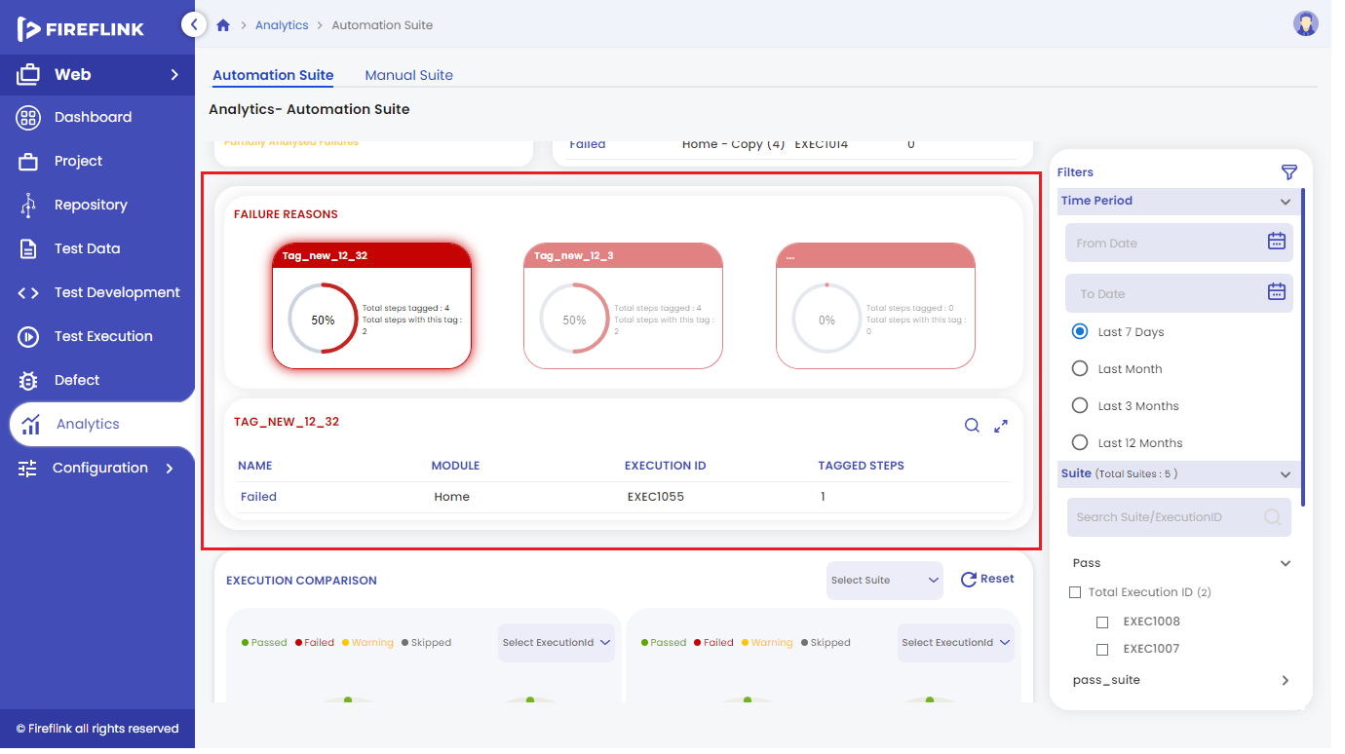

* It is a card which gets created on tagging the failed step of a script, with a respective name given to the tag.
* In this card, we display the total steps tagged count and the step with particular tag count.
* By default, three cards will be displayed. If more cards are present, then the section will be scrollable.
* Upon clicking on any particular card, the list of the script's details will be displayed below in table form.

1. **Execution Comparison**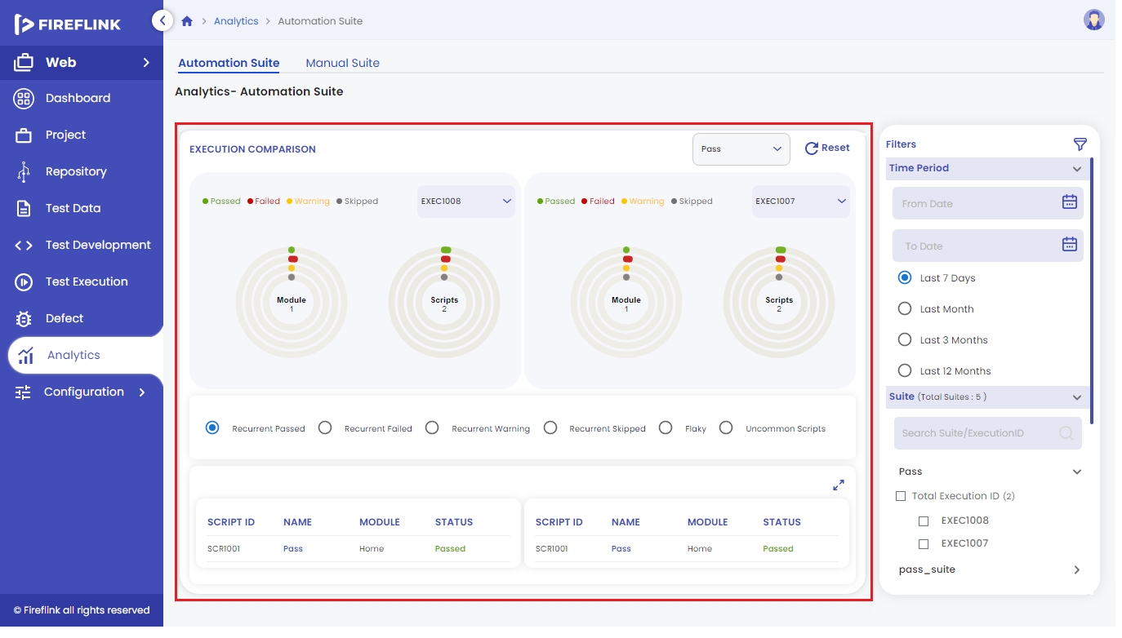

* It is a Section where users can compare the same suite, with different Execution ID.
* In this section users can compare the scripts status such as (Recurrent Passed, Recurrent Failed, Recurrent Warning, Recurrent Skipped, Flaky, Uncommon Scripts).
  + **Recurrent Passed** – These are the status of Scripts which got passed on every execution done by the user.
  + **Recurrent Failed** – These are the status of Scripts which failed on every execution done by the user.
  + **Recurrent Warning** – These are the status of Scripts which get failed as warning on every execution done by the user**.**
  + **Recurrent Skipped** – These are the status of Scripts when a particular step inside it gets failed and stop executing the further steps while execution is completed.
  + **Flaky** – These are the status of Scripts which get failed and passed on every execution done by the user.
  + **Uncommon Scripts** – These are the status of scripts which are not common in any one of the Execution ID.
* Once the user selects the suite name in the drop down given.
* Again in the two sections provided for comparison, where users should select the Execution IDs in both the dropdowns provided.
* Then by default ‘Recurrent Passed’ script will be displayed in the table provided below the two compare sections.
* Based on clicking the radio buttons, the respective result will be displayed below.